dh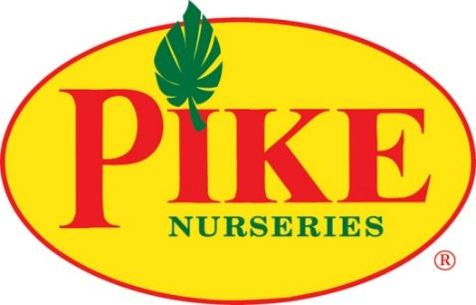

**For More Information:**

Brianna Poplaskie/Caroline Day

BRAVE Public Relations

404.233.3993

bpoplaskie@[emailbrave](mailto:bpoplaskie@emailbrave.com).com  
[cday@emailbrave.com](mailto:cday@emailbrave.com)

**FOR IMMEDIATE RELEASE**

**Pike Nurseries Helps Homeowners Prepare for Fall with Expert Garden and Lawn Care Tips***Southeast horticultural experts share advice for keeping plants thriving during cooler months*

**ATLANTA (Sept. 9, 2024)** – As the crisp air of autumn approaches, Pike Nurseries reminds homeowners that now is the ideal time to prep gardens and lawns for the cooler months ahead. With over 60 years of expertise and experience, Pike Nurseries offers insight and hands-on tips to help gardeners transition smoothly from summer to fall.

**Fall Garden Preparation**  
Fall is a crucial period for planting and maintaining gardens. Pike Nurseries recommends planting cool-season vegetables, such as kale, broccoli and lettuce, as well as fall-blooming flowers like pansies, mums and asters. These plants thrive in cooler temperatures, adding vibrant color and fresh produce to the garden throughout the season.

In addition, Pike Nurseries advises green thumbs to clean up garden beds by removing spent summer plants, weeds and debris. This cleanup not only helps prevent the spread of disease but also prepares the soil for new plantings. Adding a layer of mulch will also help retain moisture, regulate soil temperature and reduce weed growth.

**Lawn Care Tips**  
For a lush, green lawn through the fall, Pike Nurseries offers guidance on lawn care and maintenance. Aeration is a key step in promoting healthy grass growth. By loosening compacted soil, aeration allows water, nutrients and oxygen to reach the roots more effectively.

Overseeding with cool-season grasses, such as fescue, is another important practice. Overseeding fills in bare patches and enhances the overall appearance of the lawn. Pike Nurseries also recommends applying a balanced fertilizer to provide essential nutrients and strengthen the lawn's root system before winter.

**Expert Advice**   
Pike Nurseries is committed to helping gardeners of all skill levels achieve success in their fall garden and create their ideal lawns this fall. In-store experts are available to answer questions, provide personalized advice and recommend the best products for each homeowner's specific needs.

For more tips and tricks from Pike Nurseries’ garden experts, visit [pikenurseries.com](https://www.pikenursery.com/) or connect on [Facebook](http://facebook.com/pikenurseries), [Instagram](https://www.instagram.com/pikenurseries/), [Pinterest](http://pinterest.com/pikenurseries/) and [X](http://twitter.com/pikenurseries).

**ABOUT PIKE NURSERIES**Ever committed to its customers’ gardening success, Pike Nurseries takes pride in taking the guesswork out of gardening and helping its customers play in the dirt. Offering superior knowledge, quality and selection in a friendly, caring environment, Pike Nurseries has been a Southern icon for over 60 years. Founded in 1958 by Pete Pike, its ability to adapt to market conditions and community needs has made it a respected Southern institution. As Atlanta’s oldest garden chain, Pike Nurseries has nineteen retail locations, fifteen in the Atlanta, Ga. area and four in the Charlotte, N.C. area. Led by President Monte Enright, Pike Nurseries looks forward to continued growth as it keeps Atlanta and Charlotte beautiful, one landscape at a time.